***Requirements specification v1.0***

1. **Introduction**
   1. **Purpose**

This document describes a system that will be developed by Four Walls Software for The Council. This system will allow for different waste management scenarios to be configured, model these scenarios accordingly, and output results that The Council can use to empty historic landfill sites.

* 1. **Definitions**

“We”: Four Walls Software.

“Client”: The Council.

“RESTful Web Service”: A recognised and extensible architectural style.

* 1. **References**

This document is based on a scoping meeting with the client. Documented via email on the 2nd of September 2024.

1. **System architecture**
   1. **System context**

Figure 1 shows a system context diagram and provides a high-level overview of the system in line with the C4 diagramming style.

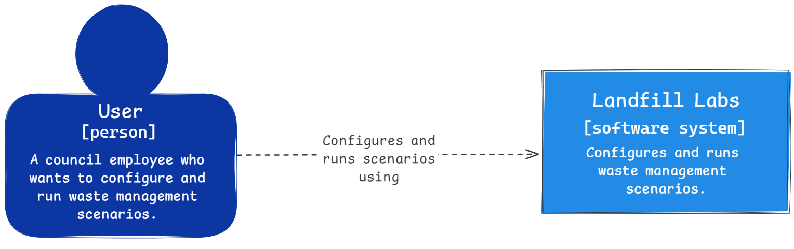

Figure 1: System context diagram.

* 1. **System containers**

Figure 2 shows a system container diagram and provides a mid-level view of the system in line with the C4 diagramming style.

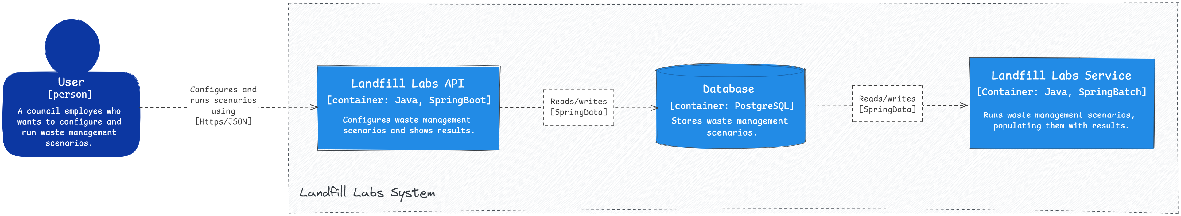

Figure 2: System container diagram (zoom-in to view details).

* 1. **System logic**

The following subsections describe the logic of components that make-up the worker service, which is responsible for running waste management scenarios.

* + 1. **RunModel**

The main method for modelling waste scenarios. This method returns the scenario results: the travel duration, the process duration, and the total duration.

* + 1. **EstimateWasteSplit**

Calculates the estimated waste split. If less then 1250 cubic meters waste in total, 50% plastic/glass and 50% paper. Otherwise, 30% plastic/glass, 50% paper and 20% metallic.

* + 1. **FindViableCentres**

Finds viable recycling centres. If metallic/paper waste is present, all centres within 3 hours (inclusive) are considered viable. If there is no metallic/paper waste, only Alpha and Beta centres are considered viable.

* + 1. **FindOptimalCentre**

Orders the viable recycling centres. The nearest centres are given the highest priority. If there are multiple nearest centres, the one that is the highest generation (i.e., gamma over beta) will be given the highest priority. If there are multiple centres in the same location with the same generation, the one that has been active for less years is given the highest priority. The highest priority centre is considered optimal and returned. In the event of there being two or more highest priority centres, an optimal centre is chosen at random.

* + 1. **CalculateTravelDuration**

Calculates the travel duration. This involves calculating the number of round trips that the truck (capable of carrying up to 20 cubic meters of waste) needs to make, and then multiplying this number of trips by the round-trip journey time (in hours).

* + 1. **CalculateProcessDuration**

Calculates the time taken to process the waste at the recycling centre. The rate of processing depends on the type of recycling centre: 1 cubic meters per hour for type Alpha and 1.5 cubic meters per hour for type Beta. For type Gamma centres it also depends on waste types: 1.5 cubic meters per hour for plastic, 2.0 for metallic, and 3.0 for paper.

* + 1. **Assumptions and constraints**
* This initial version of the system will be used by a max 1 user at a time.
* A transport can handle a maximum 20 cubic meters of waste (of multiple types).
* Only 1 transport/truck is available.
* Centres cannot do processing while being filled.

1. **Functional requirements**
   1. **Configuring scenarios**

The Landfill Labs API will allow for scenarios to be configured by exposing the following endpoints:

* [POST] /Scenario: Creates a new (empty) scenario. Marked as unfinalized (i.e., not ready for the Worker Service) by default.
* [GET] /Scenario/{id}: Reads a single scenario. Returns data for the Historic Landfill Site, Sanitary Landfill Sites, and Recycling Centres within the specified scenario. Scenario results are returned if available.
* [PATCH] /Scenario/{id}: Marks a scenario as finalised (i.e., ready for the Worker Service).
* [DELETE] /Scenario/{id}: Deletes a scenario.
* [POST] /Historic: Creates a new historic landfill site.
* [GET] /Historic/{id}: Reads a historic landfill site.
* [DELETE] /Historic/{id}: Deletes a historic landfill site.
* [POST] /Recycling: Creates a recycling centre.
* [GET] /Recycling/{id}: Reads a recycling centre.
* [DELETE] /Recycling/{id}: Deletes a recycling centre.
  1. **Viewing scenario results**

Results will also be available via the Landfill Labs API via the following endpoint:

* [GET] /Scenario/{id}: Reads a single scenario. Returns data for the composite Historic Landfill Site and Recycling Centres. Scenario results are returned if available.

Note that the results will only be available after the Worker Service has completed the scenario job.

1. **Non-functional requirements**
   1. **Security considerations**

The system will be developed in accordance with established software security best practices.

1. **Approvals**

Signed on behalf of Four Walls Software: *Sam A*

*Mauro M*

Signed on behalf of the client: *Morgan B*